Do-while assignment (vansh aneja 2410990316)

1. Guess the Number Game:  
   Implement a simple number guessing game. Generate a random number between 1 and  
   100, and ask the user to guess the number. Provide hints (higher/lower) until  
   the correct number is guessed. Use a do-while loop.

#include <stdio.h>

#include <stdlib.h>

#include <time.h>

int main() {

srand(time(0));

int target = rand() % 100 + 1;

int guess;

printf("Welcome to the Number Guessing Game!\n");

printf("Guess a number between 1 and 100.\n");

do {

printf("Enter your guess: ");

scanf("%d", &guess);

if (guess > target) {

printf("Too high! Try again.\n");

} else if (guess < target) {

printf("Too low! Try again.\n");

} else {

printf("Congratulations! You guessed the correct number.\n");

}

} while (guess != target);

return 0;

}

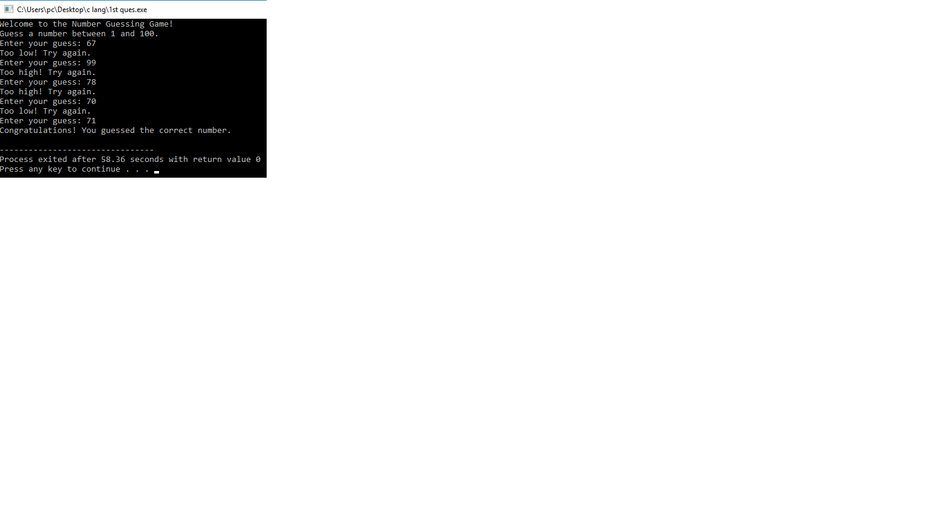

1. Sum of Digits until Single  
   Digit: Write a program to repeatedly calculate the sum of the digits of a  
   number until a single-digit number is obtained. Print the resulting  
   single-digit number. Use a do-while loop.

#include <stdio.h>

int main() {

int num, sum;

printf("Enter a number: ");

scanf("%d", &num);

do {

sum = 0;

while (num > 0) {

sum += num % 10;

num /= 10;

}

num = sum;

} while (num >= 10);

printf("Single-digit sum: %d\n", num);

return 0;

}

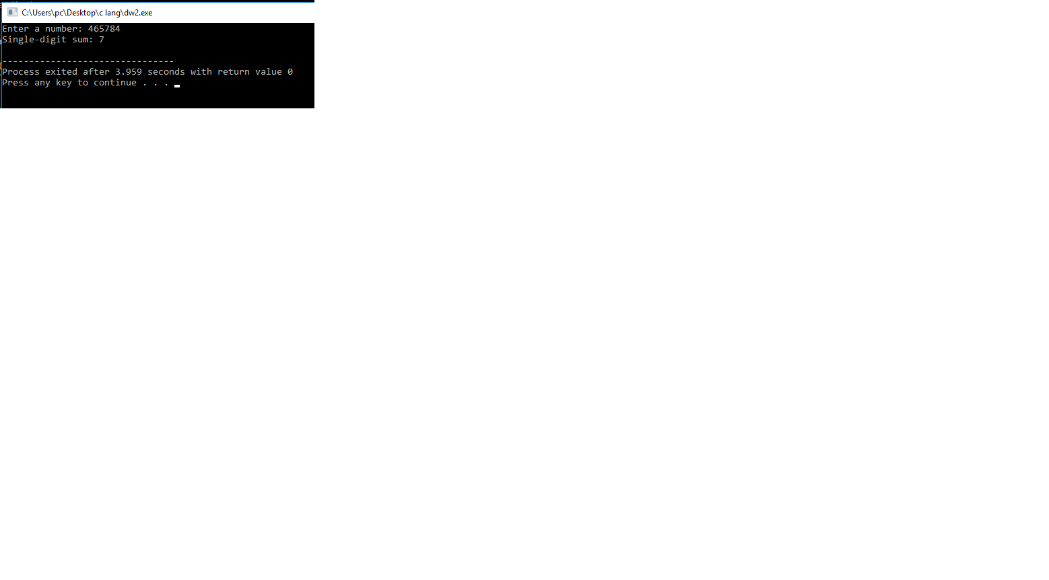

1. Multiplication Table with  
   Do-While: Write a program to print the multiplication table of a given number  
   using a do-while loop. The user should input the number.

#include <stdio.h>

int main() {

int num, i = 1;

printf("Enter a number: ");

scanf("%d", &num);

printf("Multiplication table of %d:\n", num);

do {

printf("%d x %d = %d\n", num, i, num \* i);

i++;

} while (i <= 10);

return 0;

}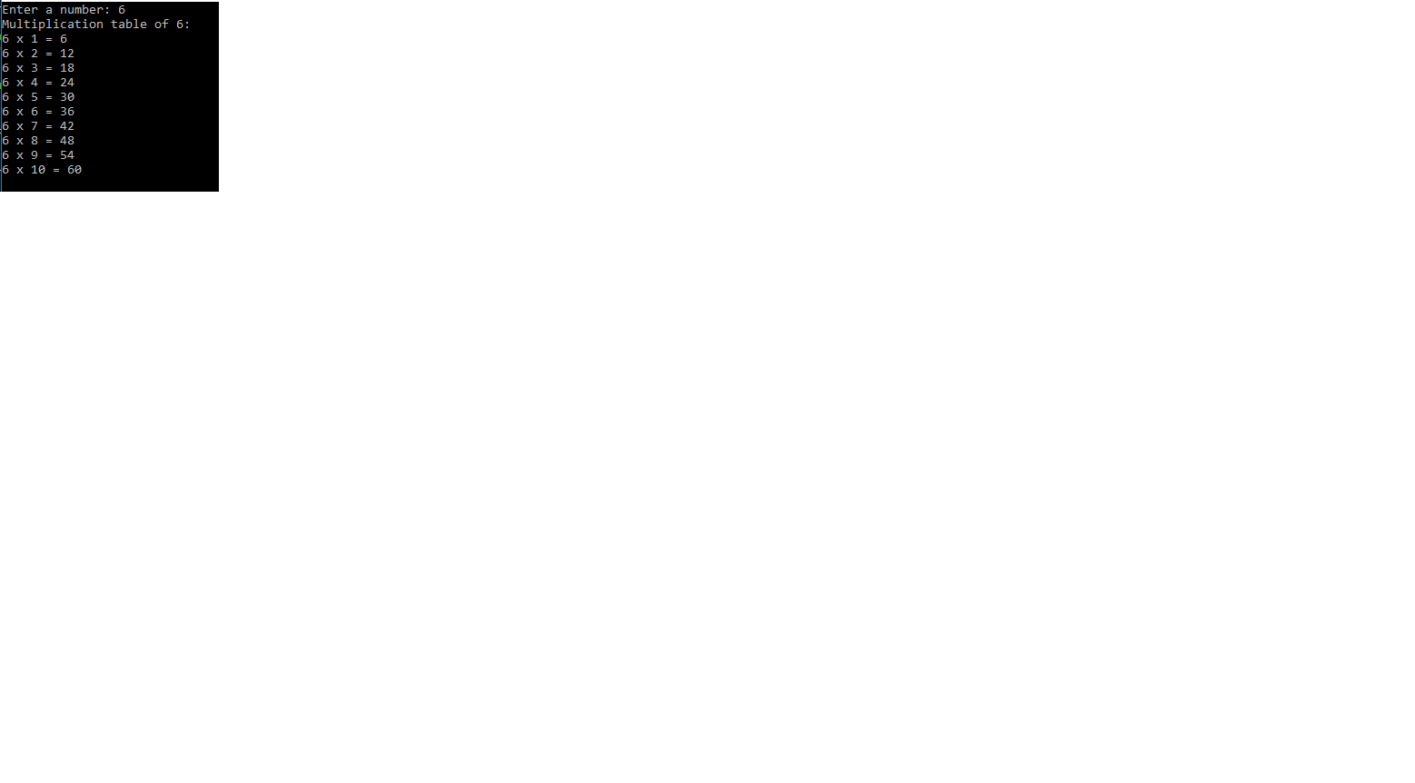

1. Menu-Driven Calculator:  
   Implement a simple menu-driven calculator program that performs addition,  
   subtraction, multiplication, and division based on user input. Continue to  
   display the menu until the user chooses to exit using a do-while loop.

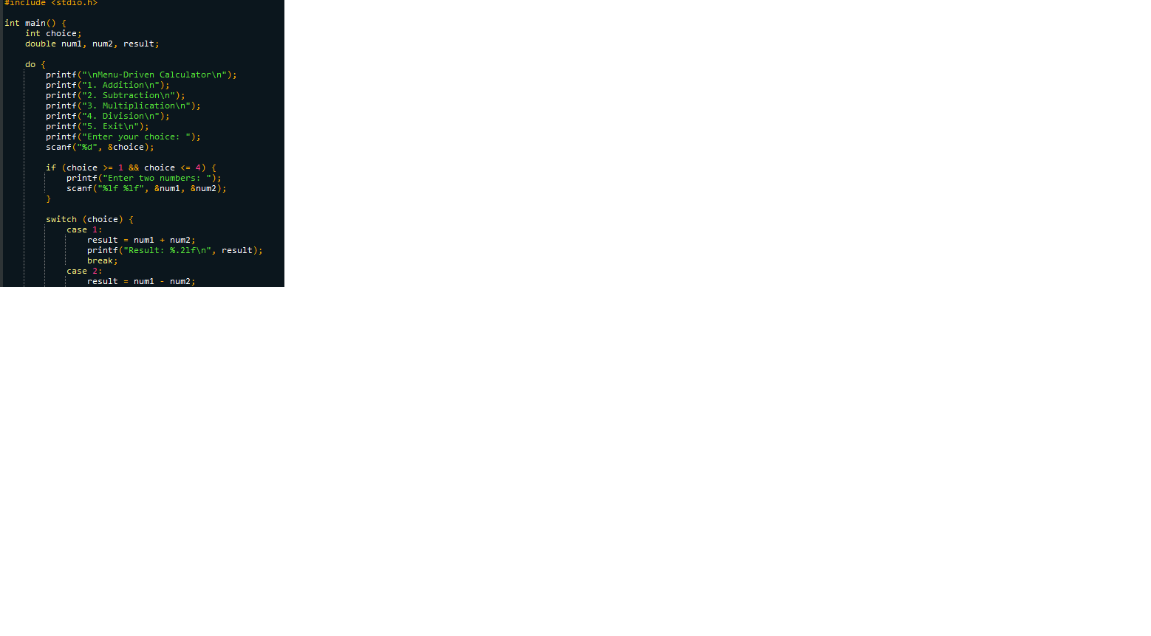

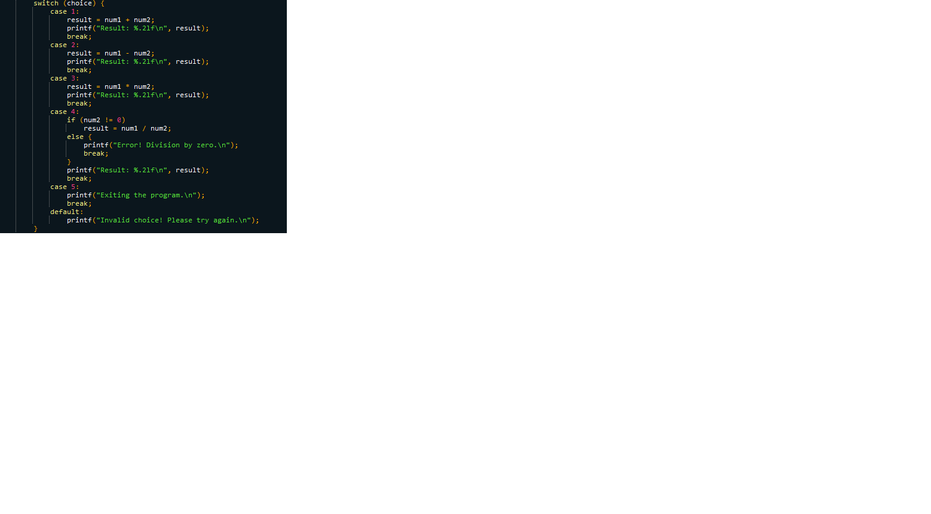

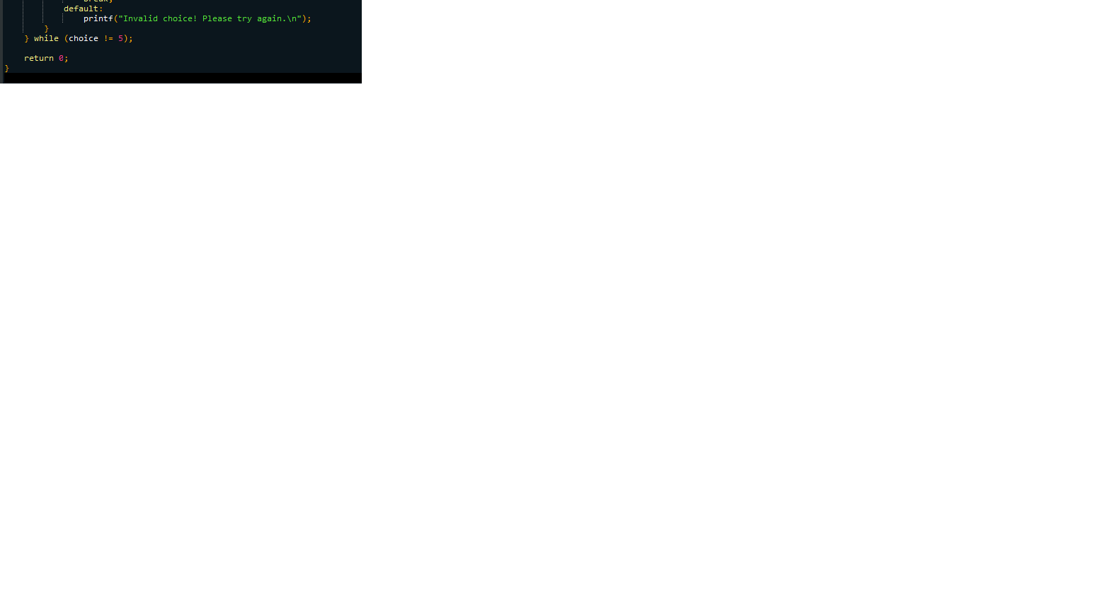

Output :

